Name: Dhruvi Swadia

Roll No: 3501

**Data Visualization Assignment**

Printing Working Directory:

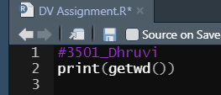

Output:

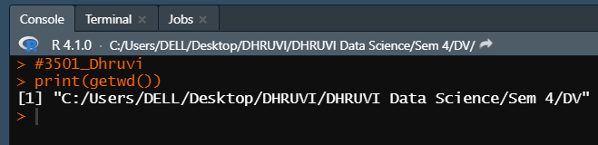

Loading Library Tidy verse:



Output:

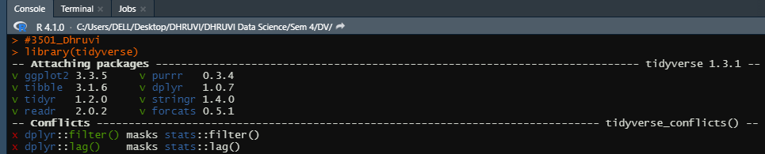

Loading Data:



Output:

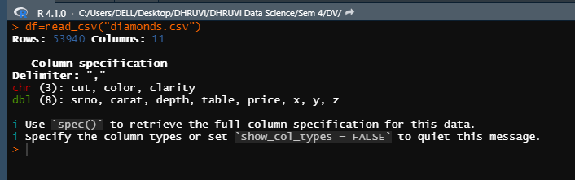

Cleaning Data (Printing the sum of na values, checking the cols with na values, filter the data, remove unwanted column, view the summary of the filtered data):

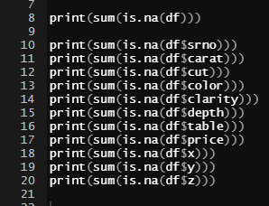

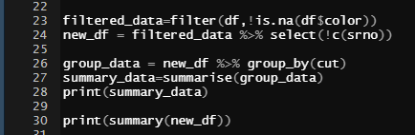

Output:

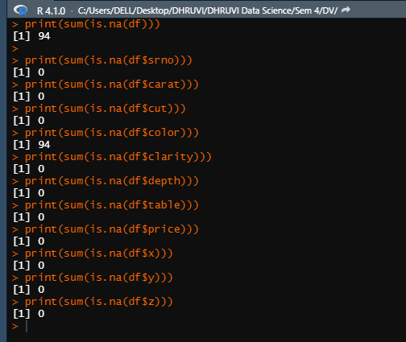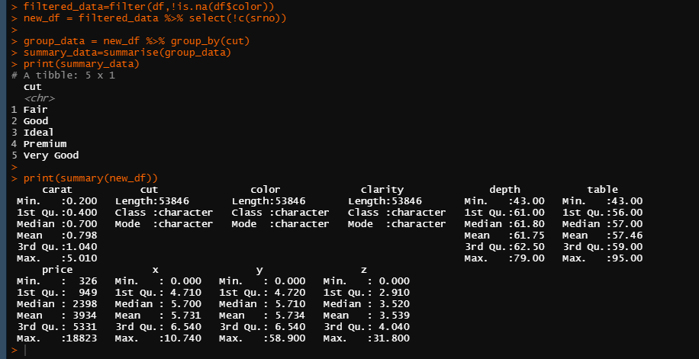

Visualizations:

